**R Code for Examples in the book**

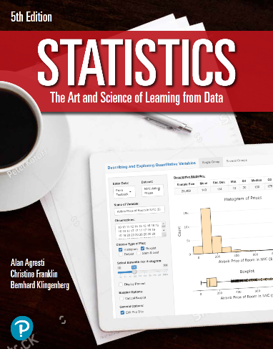

***“Statistics: The Art and Science of Learning from Data”***

**by Agresti, Franklin and Klingenberg, 5th edition**

**Chapter 5**

**Example 2: Fairness of Rolling Dice – Randomness**

## Rolling a fair 6-sided die 100 times

set.seed(22) # for reproducibility  
rolls <- sample(6, 100, replace = TRUE)

## To obtain the cumulative proportion of the rolls

sixes <- rolls == 6  
frequency <- cumsum(sixes)  
cumulativeFrequency <- frequency / 1:100  
cumulativeSum <- cumsum(sixes)  
cumulativeProportion <- cumulativeSum / 1:100

## Plot of the cumulative proportion of the rolls

plot(cumulativeProportion, type = 'l',  
 main = 'The Cumulative Proportion of Times a 6 Occurs, \n for a Simulation of 100 Rolls of a Fair Die',  
 xlab = 'Trial Number', ylab = 'Cumulative Proportion')

